Communicating Multimodal Wayfinding Messages for Visually Impaired People via Wearables

【Summary】:

By combining multi-mode pathfinding information with wearable devices, we can provide tailored information for pathfinding and reduce the cognitive burden. This research proposes a framework for multi-mode pathfinding communication through smart watches. The framework contains four modes: audio, voice, haptic and visual. Audio and voice messages are transmitted using bone-conducting headphones, allowing the ear to focus freely on the environment. When using a smart watch, vibration is directly transmitted to sensitive parts of the body (ie the wrist), making it easier to sense the vibration. Icons and short text feedback can be viewed on the watch's display for hands-free navigation.

【MESSAGE FRAMEWORK】：(Detail in Paper)

The messages are sorted in four different categories according to their content and importance: navigation instructions, orientation messages, accessibility messages and alerts.

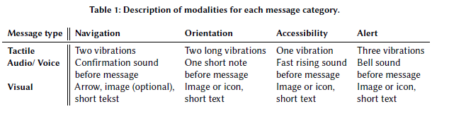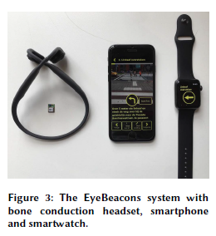

【Apparatus】:

iPhone+Apple Watch

【Procedure】：

The effectiveness of the framework was tested in an urban setting in Amsterdam, the Netherlands. We designed the route to include situations users typical encounter in an urban environment (noisy roads, stairs, road crossings, squares, construction work and obstacles on the road), figure 4.

After an indoor introduction, users walked the predetermined route of 1 kilometre and received a total of 23 wayfinding instructions via the headphone (audio/voice), smartwatch (visual) and smartphone (tactile (vibration)). While the smartwatch was envisioned to deliver the vibrations, limitations of the smartwatch did not allow us to communicate the desired patterns. Hence, it was decided to use the smartphone mounted on the arm to transmit the vibrations.

【Measures of user pressure】：

SUS

RTLX

【Results】: (Detail in Paper)

P1 and P3 experienced almost no mental load, while P2 experienced moderate load and P4 experienced high mental load. P4 also experienced a higher physical effort (moderate) than the other participants (low). All other task load experiences were rated close to the other participants.

P1 and P2 were positive, while P3 was not satisfied with the device. P4 could not use the headset because of a Bluetooth hearing aid. P1, P3 and P4 were satisfied with the amount of feedback from the system...

【Conclusion】：

Participants walked along a predetermined route through the city of Amsterdam, receiving arm vibrations via a smartphone, receiving screen messages via a smart watch, and receiving audio and voice feedback via a bone-conduction headset. Both vibration and audio tunes are recognized by all participants, but it is difficult to distinguish. It's unclear whether this is caused by the selected indicator or whether the user cannot re-understand the meaning of different indicators. Prior to field testing, it was confirmed that participants remembered different patterns.

